Rite of Christian Initiation of Adults

FROM THE

uNITED STATES CONference of catholic bishops
Each year on Holy Saturday during the Easter Vigil, thousands of are baptized into the Catholic Church in the United States. Parishes welcome these new Catholics through the Rite of Christian Initiation of Adults (RCIA). Listed below are some questions and answers about RCIA.

What is RCIA?

RCIA, or Rite of Christian Initiation of Adults is the formal process through which adults come into the Church, whether they had no formal connection to a religion or denomination previously, if they did, or if they were baptized Catholic but then never completed their instruction in the Faith and the reception of the other Sacraments.

RCIA is a Rite, because it is a ritual, a process. It follows the format of the first centuries of the Christian Church as those were interested in the Faith would learn more about it, while being guided in a spirit of prayer and preparation through each of the steps of the process, pointing towards the reception of Baptism, Confirmation, and/or Holy Eucharist at the Easter Vigil.

As a process, and one with 2,000 years of wisdom behind it, RCIA is a welcoming place where adults can walk with God and discern where He is leading them without feeling like they have to make a commitment right way, simply by attending a session. It is a year-long process normally, but for some it may be longer if they are not ready. The beauty of RCIA is that it challenges each adult through prayer and learning to really find themselves and be sure they are ready, without any fear of judgment or coercion.

What are the steps of RCIA?
Prior to beginning the RCIA process, an individual comes to some knowledge of Jesus Christ, considers his or her relationship with Jesus Christ and is usually attracted in some way to the Catholic Church. This period is known as the Period of Evangelization and Precatechumenate. For some, this process involves a long period of searching; for others, a shorter time. Often, contact with people of faith and a personal faith experience lead people to inquire about the Catholic Church. After a conversation with a priest, or RCIA director, the person, known as an "inquirer," may seek acceptance into the Order of Catechumens, through the Rite of Acceptance. During this Rite, the inquirer stands amidst the parish community and states that he or she wants to become a baptized member of the Catholic Church. The parish assembly affirms this desire and the inquirer becomes a Catechumen.

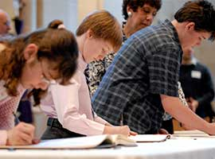
The Period of the Catechumenate can last for as long as several years or for a shorter time. It depends on how the person is growing in faith, what questions they encounter along the way, and how God leads them on this journey. During this time, the Catechumens consider what God is saying to them in the Scriptures, what changes in their life they need to make to respond to God's inspiration, and what Baptism in the Catholic Church means. When a Catechumen and the priest and the parish team working with him or her believes the person is ready to make a faith commitment to Jesus in the Catholic Church, the next step is the request for baptism and the celebration of the Rite of Election. Even before the Catechumens are baptized, they have a special relationship to the Church.

The Rite of Election includes the enrollment of names of all the Catechumens seeking baptism at the coming Easter Vigil. Typically, on the first Sunday of Lent, the Catechumens, their sponsors and families gather at the cathedral church. The Catechumens publicly express their desire for baptism to the diocesan bishop. Their names are recorded in a book and they are called the Elect.

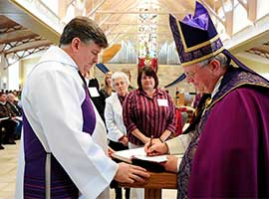
The days of Lent are the final Period of Purification and Enlightenment leading up to the Easter Vigil. Lent is a period of preparation marked by prayer, study, and spiritual direction for the Elect, and prayers for them by the parish communities. The Celebration of the Sacraments of Initiation takes place during the Easter Vigil Liturgy on Holy Saturday when the Elect receives the sacraments of Baptism, Confirmation and Holy Eucharist. Now the person is fully initiated into the Catholic Church.

As a newly initiated Catholic, they continue their formation and education continue in the Period of the Post Baptismal Catechesis, which is also called Mystagogy. This period continues at least until Pentecost. During the period the newly baptized members reflect on their experiences at the Easter Vigil and continue to learn more about the Scriptures, the Sacraments, and the teachings of the Catholic Church. In addition they reflect on how they will serve Christ and help in the Church's mission and outreach activities.

What is meant when by coming into full communion with the Church?
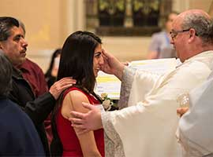
Coming into full communion with the Catholic Church describes the process for entrance into the Catholic Church for already baptized Christians. In most cases, these individuals make a profession of faith but are not baptized again. To prepare for this reception, the people, who are called Candidates, usually participate in a formation program to help them understand and experience the teachings and practices of the Catholic Church. Although some preparation may be with Catechumens preparing for baptism, the preparation for Candidates is different since they have already been baptized and committed to Jesus Christ, and many have also been active members of other Christian communities. The Candidates may be received into the Catholic Church at the Easter Vigil or at another Sunday during the year depending on pastoral circumstances and readiness of the Candidate.

